Computer Science & Information Systems
Data Management for Machine Learning – Lab Sheet
Lab Exercise 1 - Modes of data flows
- Objective:
Design and implement the simple data flows involving various data formats

Modes of data flows
a) Through REST/RPC – Synchronous mechanism for data exchange
b) Through Databases – use SQL / Custom Program to read/write into databases

Data pipeline is a method in which raw data is ingested from various data sources and then ported to data store, like a data lake or data warehouse, for analysis. Before data flows into a data repository, it usually undergoes some data processing. This is inclusive of data transformations, such as filtering, masking, and aggregations, which ensure appropriate data integration and standardization. This is particularly important when the destination for the dataset is a relational database. This type of data repository has a defined schema which requires alignment—i.e. matching data columns and types—to update existing data with new data.

As the name suggests, data pipelines act as the “piping” for data science projects or business intelligence dashboards. Data can be sourced through a wide variety of places — APIs, SQL and NoSQL databases, files, etc., but unfortunately, that data usually isn’t ready for immediate use. Data preparation tasks usually fall on the shoulders of data scientists or data engineers, who structure the data to meet the needs of the business use case. The type of data processing that a data pipeline requires is usually determined through a mix of exploratory data analysis and defined business requirements. Once the data has been appropriately filtered, merged, and summarized, it can then be stored and surfaced for use. Well-organized data pipelines provide the foundation for a range of data projects; this can include exploratory data analyses, data visualizations, and machine learning tasks.

Data pipelines consist of three key elements: a source, a processing step or steps, and a destination. In some data pipelines, the destination may be called a sink. Data pipelines enable the flow of data from an application to a data warehouse, from a data lake to an analytics database, or into a payment processing system, for example. Data pipelines also may have the same source and sink, such that the pipeline is purely about modifying the data set. Any time data is processed between point A and point B (or points B, C, and D), there is a data pipeline between those points.

1. Sources
Sources are where data comes from. Common sources include relational database management systems like MySQL, CRMs such as Salesforce and HubSpot, ERPs like SAP and Oracle, social media management tools, and even IoT device sensors.

2. Processing steps
In general, data is extracted data from sources, manipulated and changed according to business needs, and then deposited it at its destination. Common processing steps include transformation, augmentation, filtering, grouping, and aggregation.

3. Destination
A destination is where the data arrives at the end of its processing, typically a data lake or data warehouse for analysis.

In this lab exercise, you will develop a custom data flow pipeline using Python and REST APIs involving the stages as:
  - Read data from Kaggle Dataset through REST API (Source)
  - Explore the data using Python libraries (Process)
  - Load data into local PostgreSQL database (Destination)
  - Load data into AWS S3 service (Destination)
  - Schedule the data flow periodically (Orchestrate)

- Steps to be performed:
- Tools / Packages setup
- Kaggle
- Amazon Web Service
- Python
- PostgreSQL

- Sign up and login to the Kaggle portal using this link.
- Sign up and login to AWS free tier account using this link.
- Install Python on the local system using the installer available here.
- Install PostgreSQL database on the local system using the installer available here.

- Create database in PostgreSQL

- Launch the PostgreSQL Admin UI in browser using pgadmin utility
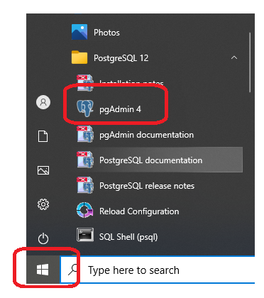

- Login to the PostgreSQL using master password
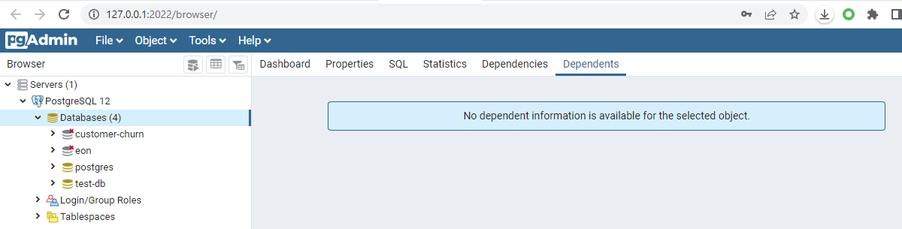

- Create a database under PostgreSQL
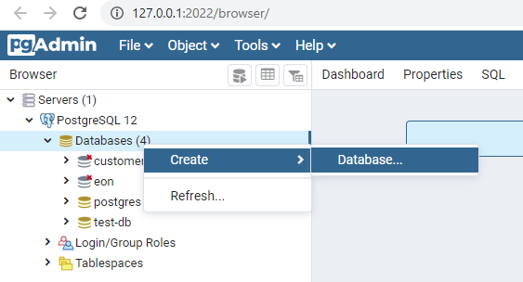

- Generate API token at Kaggle Portal

- Login to the Kaggle portal and access the settings section
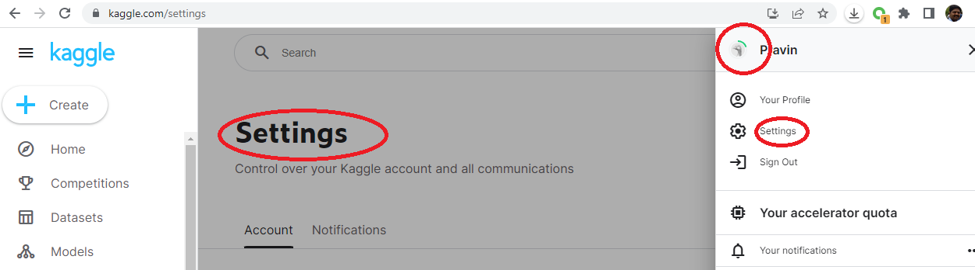

- Generate API token using “Create new token”
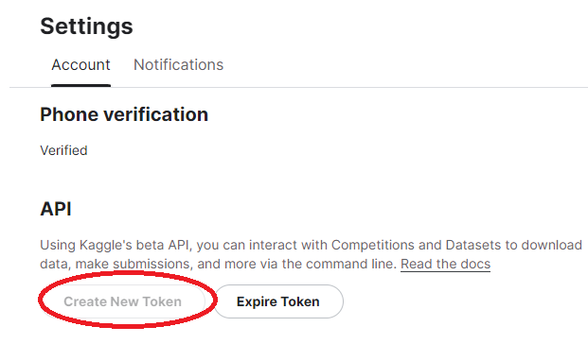

- A json file with “kaggle.json” will be downloaded.
- Create a new text file “key.txt” and just copy username and key from “kaggle.json”on two separate lines.

- Install Kaggle module on local system
- Using pip command install Kaggle module
pip install Kaggle
- Create a pipeline program
- Create a python program named “Custom_Pipeline.py” in same directory where “key.txt” file is located.
- Add the following code snippet in it to read the Kaggle keys from the keys.txt file and then load it into environment variables.
import os
from io import StringIO

#Read the Kaggle and AWS keys from keys.txt file, then load to env varaibles
keys_file = open('keys.txt', 'r')
Lines = keys_file.readlines()

keys = []
for line in Lines:
line = line.strip()
keys.append(line)

KAGGLE_USERNAME = keys[2]
KAGGLE_KEY = keys[3]

#Load keys to env varaibles
os.environ['KAGGLE_USERNAME'] = KAGGLE_USERNAME
os.environ['KAGGLE_KEY'] = KAGGLE_KEY

print(os.environ['KAGGLE_USERNAME'])
print(os.environ['KAGGLE_KEY'])

- On terminal, execute the program to check whether keys are getting read or not.
python Custom_Pipeline.py
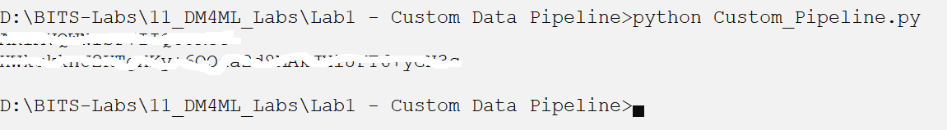

- Download the dataset using Kaggle API
- Using the Kaggle API read the Telecom dataset
#Read the dataset from Kaggle
from kaggle.api.kaggle_api_extended import KaggleApi

dataset = 'abhinav89/telecom-customer'
path = 'datasets/telecom-customer'

api = KaggleApi()
api.authenticate()
api.dataset_download_files(dataset, 'Telecom_customer churn.csv', path, unzip=True)

- Verify the download in the same directory
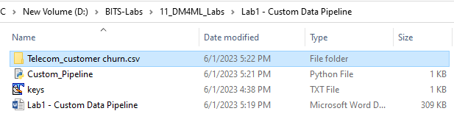
- Load data into Python Pandas and do some data exploration
- Read the data into Python dataframe
import pandas as pd
df_copy = pd.read_csv('Telecom_customer churn.csv/Telecom_customer churn.csv')
print(len(df_copy))

df = df_copy.copy()

- Look for data properties
print("row x columns of data ", df.shape) # row x columns of data
print("size of data ", df.size) # size of data

print("##########################################################")
df.info()
print("##########################################################")

- Identify and drop the missing values
# Do some data preparation
#Find out missing values
miss = df.isnull().sum().sort_values(ascending = False).head(44)
#Drop missing values
df.dropna(inplace=True)
print("Number of missing values : AFTER ", sum(df.isnull().sum()>0))

- Export the prepared dataset into a new CSV file “'prepared_file.csv'”
- Copy the prepared dataset into a new file “”.
#Move the prepared dataset to a new file
df.to_csv('prepared_file.csv', header=False)
with open("prepared_file.csv", mode='w', newline='\n') as f:
df.to_csv(f, sep=",",index=False, line_terminator='\n',encoding='utf-8')

print("Prepared file exported!")

- Verify the export of new file in the same directory.
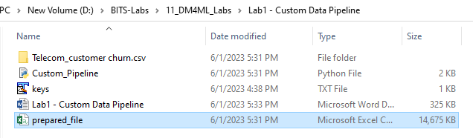

- Create a table in PostgreSQL using Python
- Establish a connection to the PostgreSQL database
#Connect to the PostgreSQL database
import psycopg2
import csv

conn = psycopg2.connect(database="test-db",
user='postgres', password='password',
host='127.0.0.1', port='5432'
)

conn.autocommit = True
cursor = conn.cursor()
print("Connected to Db!")

- Create a table named “test” under the database created in the step B3.
#Create a table "test" using some of the columns from dataset
sql1 = '''CREATE TABLE test(rev_Mean float, mou_Mean float, totmrc_Mean float, da_Mean float, ovrmou_Mean float, ovrrev_Mean float, vceovr_Mean float, datovr_Mean float, roam_Mean float,change_mou float,change_rev float, drop_vce_Mean float, drop_dat_Mean float, blck_vce_Mean float, blck_dat_Mean float, unan_vce_Mean float, unan_dat_Mean float, plcd_vce_Mean float, plcd_dat_Mean float, recv_vce_Mean float, recv_sms_Mean float, comp_vce_Mean float, comp_dat_Mean float, custcare_Mean float, ccrndmou_Mean float, cc_mou_Mean float, inonemin_Mean float, threeway_Mean float, mou_cvce_Mean float,mou_cdat_Mean float, mou_rvce_Mean float,owylis_vce_Mean float, mouowylisv_Mean float, iwylis_vce_Mean float, mouiwylisv_Mean float, peak_vce_Mean float, peak_dat_Mean float, mou_peav_Mean float, mou_pead_Mean float, opk_vce_Mean float, opk_dat_Mean float, mou_opkv_Mean float, mou_opkd_Mean float, drop_blk_Mean float, attempt_Mean float, complete_Mean float, callfwdv_Mean float, callwait_Mean float, churn int, months int, uniqsubs int, actvsubs int, new_cell varchar(30), crclscod varchar(30), asl_flag varchar(30), totcalls int, totmou float,totrev float,adjrev float, adjmou float, adjqty float, avgrev float,avgmou float,avgqty float,avg3mou float,avg3qty float,avg3rev float,avg6mou float,avg6qty float,avg6rev float, prizm_social_one varchar(30), area varchar(50),dualband varchar(30),refurb_new varchar(30), hnd_price float,
phones float, models float, hnd_webcap varchar(30), truck float, rv float, ownrent varchar(30), lor float, dwlltype varchar(30), marital varchar(30), adults float, infobase varchar(30), income float, numbcars float, HHstatin varchar(30), dwllsize varchar(30),
forgntvl float, ethnic varchar(30), kid0_2 varchar(30), kid3_5 varchar(30), kid6_10 varchar(30), kid11_15 varchar(30),
kid16_17 varchar(30), creditcd varchar(30), eqpdays float,Customer_ID int);'''

cursor.execute(sql1)
print("New Table created")

- Verify the table is created under “test-db” in PostgreSQL
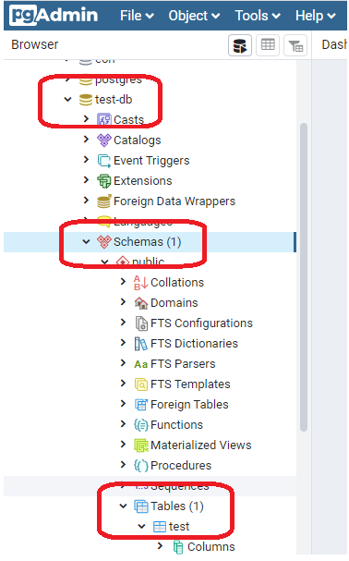

- Add the code to write data into “test” table.
#Write the data from prepared file to test table
with open('prepared_file.csv', 'r') as f:
next(f) # Skip the header row.
cursor.copy_from(f, 'test', sep=',')

print("Records inserted")

- Read data back from the table “test”.
#Read the data back from the table
indx = 0
sql2 = '''select * from test;'''
cursor.execute(sql2)
for i in cursor.fetchall():
#print(i)
indx = indx + 1

print("Records retrieved: ", indx)

- Add the code to drop table if already exists.
sql = '''DROP TABLE test;'''
cursor.execute(sql)
print("Existing Table dropped")

conn.commit()
conn.close()

- Create AWS IAM user
- Create AWS IAM user following the steps given here.
- Create security credentials for the user created in above step following the instructions given here.
- Copy the “Access key ID” and “Secret access key” into “keys.txt” file.
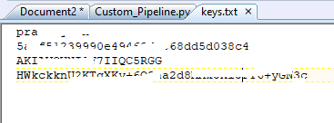
- Create AWS S3 bucket
- Follow the instructions given here to create bucket (folder) in AWS S3 service.
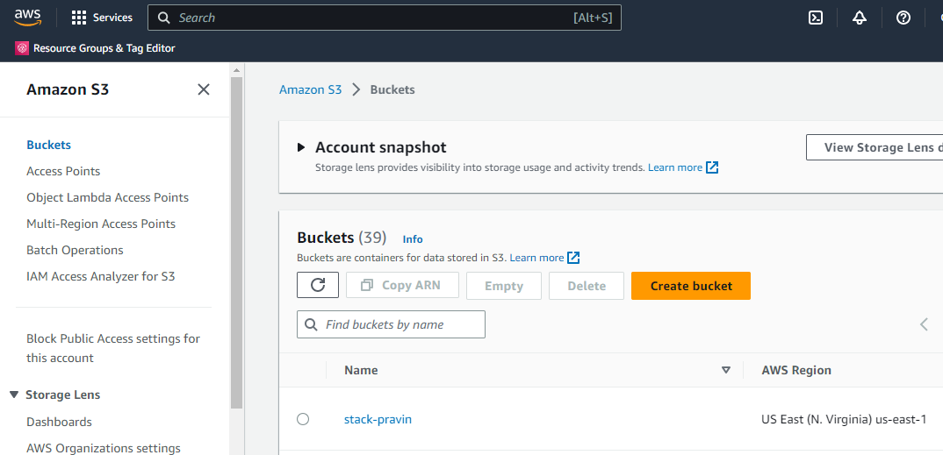

- Note down the name of the bucket.

- Add code to read and load AWS access keys into environment variables
- Read the AWS keys from “keys.txt” file
KAGGLE_USERNAME = keys[0]
KAGGLE_KEY = keys[1]

AWS_ACCESS_KEY_ID = keys[2]
AWS_SECRET_ACCESS_KEY = keys[3]

- Load them into environment variable
#Load keys to env varaibles
os.environ['KAGGLE_USERNAME'] = KAGGLE_USERNAME
os.environ['KAGGLE_KEY'] = KAGGLE_KEY
os.environ['AWS_ACCESS_KEY_ID'] = AWS_ACCESS_KEY_ID
os.environ['AWS_SECRET_ACCESS_KEY'] = AWS_SECRET_ACCESS_KEY

print(os.environ['KAGGLE_USERNAME'])
print(os.environ['KAGGLE_KEY'])
print(os.environ['AWS_ACCESS_KEY_ID'])
print(os.environ['AWS_SECRET_ACCESS_KEY'])

- Add the prepared dataset into the AWS S3 bucket
- Use the below code to upload the dataframe content to the S3bucket
#Load prepared data into a data lake i.e. AWS S3 bucket
import boto3

#Creating Session With Boto3.
session = boto3.Session(
aws_access_key_id=AWS_ACCESS_KEY_ID,
aws_secret_access_key=AWS_SECRET_ACCESS_KEY
)

#Creating S3 Resource From the Session.
s3_res = session.resource('s3')
bucket_name = 'stack-pravin'
s3_object_name = 'prepared_file.csv'

csv_buffer = StringIO()
df.to_csv(csv_buffer)

s3_res.Object(bucket_name, s3_object_name).put(Body=csv_buffer.getvalue())

print("Dataframe is saved as CSV in S3 bucket.")

- Verify the content of the AWS S3 bucket.
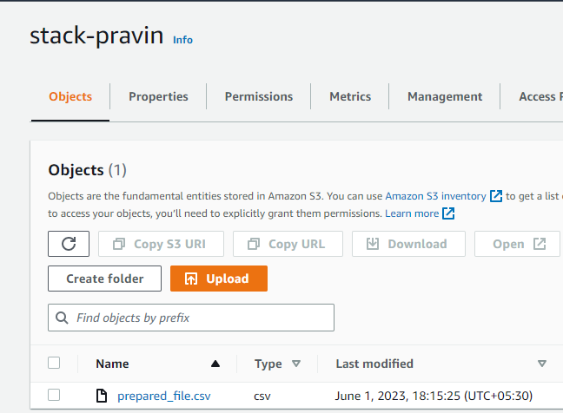

- Orchestrate the pipeline to execute at regular interval
- Use the code given in the “Custom_Pipeline_2.py” file to run the pipeline at interval of 1 minutes.

- Outputs/Results:
- Telecom dataset is downloaded into local directory
- Prepared dataset is exported into a file in local directory
- Pandas dataframe content are loaded into the PostgreSQL database table
- Pandas dataframe content are uploaded as CSV file into AWS S3 bucket
- Data pipeline is executing at interval of 1 minutes

- References:
- IBM: Data Pipeline
- Hazelcast: What Is a Data Pipeline?
- Snowflake: What Is a Data Pipeline?
- Kaggle Telecom customer dataset
- How to Use Kaggle API
- Download Dataset from Kaggle using API and Python

